Ministry of Education and Science of the Russian Federation

Russian Academy of Sciences

Russian fund for Basic Research
Saint Petersburg Scientific Center
of the Russian Academy of Science
Scientific Council on Condensed Matter Physics

Committee for science and higher education

of the Saint Petersburg City Government
Peter the Great St. Petersburg Polytechnic University

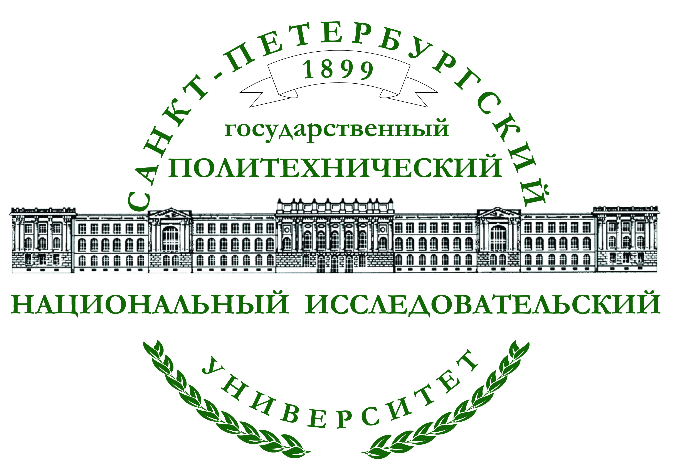
11th International Conference

Dedicated to the 100th Anniversary of
Corr.-Member of RAS V.S. Smirnov (1915-1973),
Rector of the Leningrad Polytechnic Institute
(1956-1973)

Advanced Metal Materials and Technologies

(AMMT’15)

Biennial

23-27 June 2015
St. Petersburg

Conference Chairman

Prof. I.V. Gorynin

Program Committee

Co-Chairmen

Prof. A.I. Rudskoy

Prof. M.I. Karpov

Program Committee

Prof. M.I. Alymov (Moscow)

Prof. O.A. Bannyh (Moscow)

Prof. O.A. Bogatov (Ekaterinburg)
Prof. G.C. Burhanov (Moscow)
Prof. A.M. Glezer (Moscow)
Prof. D.A. Indeytsev (Saint-Petersburg)
Prof. A.M. Dmitriev (Moscow)
Prof. A.S. Oryschenko(Saint-Petersburg)
Prof. V.Ia. Osadchiy (Saint-Petersburg)

Prof. M.R. Predtechenskiy(Novosibirsk)

Prof. V.V. Rybin (Saint-Petersburg)

Prof. V.M. Schastlivcev (Ekaterinburg)

Prof. E.N. Kablov (Moscow)

Organizing Committee

Chairman

Prof. A.I. Rudskoy (Saint Petersburg)

Organizing Committee

V. I. Betekhtin
Prof., Saint Petersburg
C.B. Vakhrushev
Prof., Saint Petersburg

E.L. Gulihandanov
Prof., Saint Petersburg
C.V. Dobatkin
Prof., Moscow

A.V.Zinoviev
Prof., Moscow

A.M. Zolotov
Prof., St. Petersburg

K.M. Ivanov
Prof., St. Petersburg

А.А.Каzakov
Prof., St. Petersburg
A.N. Kobyshev
Prof., St. Petersburg

G.E. Kodzhaspirov
Prof., St. Petersburg

N.G. Kolbasnikov
Prof., St.Petersburg

Yu.R. Kolobov
Prof., Belgorod

V.V. Korablev
Prof., Saint Petersburg
E.A. Levashov
Prof., Moscow

A.N. Lutsenko
Ph.D., Cherepovets
R.V. Staryh
Ph.D., St. Petersburg

V.A. Malyshevskiy
Prof., Saint Petersburg

I.A. Ovid’ko

Prof.,Saint Petersburg

A.A. Popovich
Prof., Saint Petersburg
O.M. Smirnov
Prof., Moscow
V.N. Tsemenko
Prof., St.Petersburg

O.V. Tolochko
Prof., St. Petersburg
A.L. Smirnova
Head of the Congress activity
department, St. Petersburg

International Advisory Committee

Prof. G.E. Kodzhaspirov (Russia)

Prof. Ch. Apostolopoulos (Greece)

Prof. B.-A. Behrens (Germany)

Prof. V. Lial (Germany)

Prof. V.Mihailov (Germany)

Prof. Borowikov (Germany)

Prof. H. Dyja (Poland)

Prof. J. Kliber (Czech Republic)

Prof.K. Malek (Czech Republic)
Prof. D. Stavrev (Bulgaria)
Dr.G.Porcu (Italy)

Scope

The objectives of the conference are to analyze and discuss the up-to-date progress of science and technology in a wide area of problems referring to the theory, technological and engineering tasks in the field of the metallurgical processes, metal, powdered and composite materials.

Topics

- Theory and Modeling of Metallurgical Processes;
- Technology of Processing and Production of Powdered, Composite Materials and Coatings;
- Liquid-Phase Metallurgical Processes;
- Technology of Plastic Processing of Metal Materials;
- Nanotechnologies in Metallurgy; Physical and Technological Problems of Severe Plastic Deformation (session is devoted to the 40th anniversary of the discovery of severe plastic deformation);
- Metal Science and Thermo-Mechanical Processing of Metals;
- Modern Methods of Diagnosis, Evaluation and Prediction of the Properties of Materials and Products.
- Theoretical and Practical Youth School "Transfer of innovative technologies into the high-tech business.

Venue and Сonditions for participation in the conference

The registration fee includes conference bag (with the conference proceedings on a USB flash drive), coffee breaks and lunch during the first day of the conference, transfer from the University to the steamer and back, payment of accommodation and food on the steamer, guide service.
11th Anniversary International Scientific and Technical Conference will be held on a comfortable steamer within 4 days. In addition to participation at the plenary and section sessions, the conference participants will visit the unique recreational (reserved) areas of the North-West region of Russia (Svirstroy: Vvedeno-Oyatsky convent, Kizhi island, Petrozavodsk, Kivach waterfall ,Mandrogi village.)

Important dates

01.05.2015 – deadline for papers to be published submission (up to10 pages) to the Organizing Committee

10.05.2015 – deadline for papers review by the members of Program and Organizing Committee
15.05.2015 – notice of papers acceptance

Proceedings will be published and also presented on a USB flash drive

Hard copy of the Conference Proceedings will be available by the advance request at the Organizing Committee for an additional fee (1200 rubles).

Rules for paper submission

The file with paper to be published (up to 10 pages) must be submitted by e-mail to the Organizing Committee: smmt15@spbstu.ru
Name of the text file with paper (marked art) and registration form ( marked Reg) must contain the name and initials of the first author. If several papers, the name of the text file must have number of the paper. For example: ivanov_ak_1.doc and ivanov_ak-reg.doc.
Upon recommendation of the Program Committee, some papers will be published in journals indexed in the Science Citation System RISC: "Scientific and technical news" and Scopus: «Metallurgy and heat treatment of metals", "Physics and Mechanics of Materials".

Rules for writing paper

The file with paper (up to 10 pages in MS Word)) must be submitted by e-mail to the Organizing Committeeю
Guidelines: bottom margin - 2.5 cm; left margin - 3 cm, right margin - 1.5 cm; font Times New Roman, size 14; indented paragraph - 1.25 cm, line spacing - 1.5.
Pictures, graphs and tables must be not less than 300 dpi. Formulas must be numbered and typed in the Microsoft Equation formula editor.

You can place an advertisement in Proceedings of the Conference.
The cost of placing 1400 characters is 15 000 rubles.

Structure of submitted papers

Initials and surname of the author (s);
Name of the report;
Information about the author (s): first name, last name, degree, place of work, country, city, e-mail or telephone contact;
Abstract and keywords;
Text of the report;
References;
Initials and surname of the author (s), place of work the author (s), abstract, keywords, references.

To register in RISC you must indicate in a separate file in MS Word:

Last name, first name
Place of work
Address (country, city)
Position, academic degree, title
TITLE (in capital letters)
Summary
Key Words
References (bibliography).

Registration

Registration fee:
- before 01.06.2015 - €550
after 01.06.2015 only by cash at registration - €600
Registration fee for students, postgraduates - €250
Accompanying persons - €450

Payment methods
Bank account to pay registration fee:

FOR EURO

Intermediary bank: 0103053393
VTB Bank (Deutschland) AG, Frankfurt am Main
SWIFT: OWHBDEFF
Beneficiary, s bank: JSC VTB BANK (OPERU BRANCH)
30 B. Morskaja str, 190000 St Petersburg, Russia
SWIFT: VTBRRUM2NWR
Beneficiary: account 40503978939040000020
St. Petersburg Polytechnic University (SPbPU),
29, Polytechnicheskaja str, St Petersburg, Russia

In the payment by bank transfer, please do not forget to write the title of the conference (AMMT’2015) and your name.

Participants wishing to pay through a bank must cover transaction charges.

Registration Form

Title:
Last Name ____________
First Name ____________
Other Names __________
Dates of birth__________
Place of birth __________
Citizenship ____________
Passport number_________
Date of issue____________
Date of expiry___________
Country of permanent residence ______
Place of visa issuing _______________
Place of work: ____________________
Organization_____________________
Address________________________
Position ________________________
E-mail__________________________
Fax____________________________
Phone__________________________
Accompanying person, if any_______

Date of arrival___________________
Date of departure________________

I am going to present a paper at the conference  No
I need an equipment to present a paper  Yes (kind of equipment)  No
I am bringing a poster  Yes  No

Please note! Copy of the first page of your passport sent by fax or by e-mail is necessary for visa proceedings. Visa support letter (official invitation) will be sent to you within 2 months (for members from EU countries within 2 weeks).

Accommodation needed:  Yes  No

!!! Participants arriving one or more days before the start of the conference and staying after the conference are kindly asked to indicate in the registration form the hotel reservation.

Booking the hotel:

Hotel “Sputnik” 
-  single room
-  double room

Address: Hotel “Sputnik”- Prosp. M.Toreza 36; metro station “Ploshchad’ Muzhestva”

Date and Place________
Signature ____________

Venue

The Conference will be held at the St. Petersburg State Polytechnic University to the address: 29 Politekhnicheskaya str., Main Education building, Conference hall (metro st. " Politekhnicheskaya ") - 1-st day; further- on the steamer 'Mikhail Sholohov'.

Youth School

Theoretical and Practical Youth School "Transfer of innovative technologies into the high-tech business” will be held within the conference. Quota for free participation has been stipulated for students, graduate students and young scientists who will be exempt from registration fee on the basis of competitive selection. To enter a contest you must: complete the appropriate registration form, attach a summary of the report and a motivational letter in which you as a potential participant argue the purpose of your participation in the conference, as well as the theme of your work.

Contact Information
Organizing Committee of the St. Petersburg State Polytechnic University

195251, St. Petersburg, Russia

Alla Smirnova
Tel / fax: +7 (812) 297 20 88

Lidia Papina

Tel/fax: +7(812) 552 85 34

e-mail: smmt15@spbstu.ru

Prof. G.E. Kodzhaspirov

gkodzhaspirov@gmail.com
Tel / fax: +7 (812) 686 43 53

Conference website:
http://www.spbstu.ru/conference/2015/ammt.asp

