Ministry of education and science of the Russian Federation
National Simulation Society
Saint Petersburg State Polytechnic University
Journal "Computer Tools in Education"
Group of TRANSAS Companies
EuroSim European Association

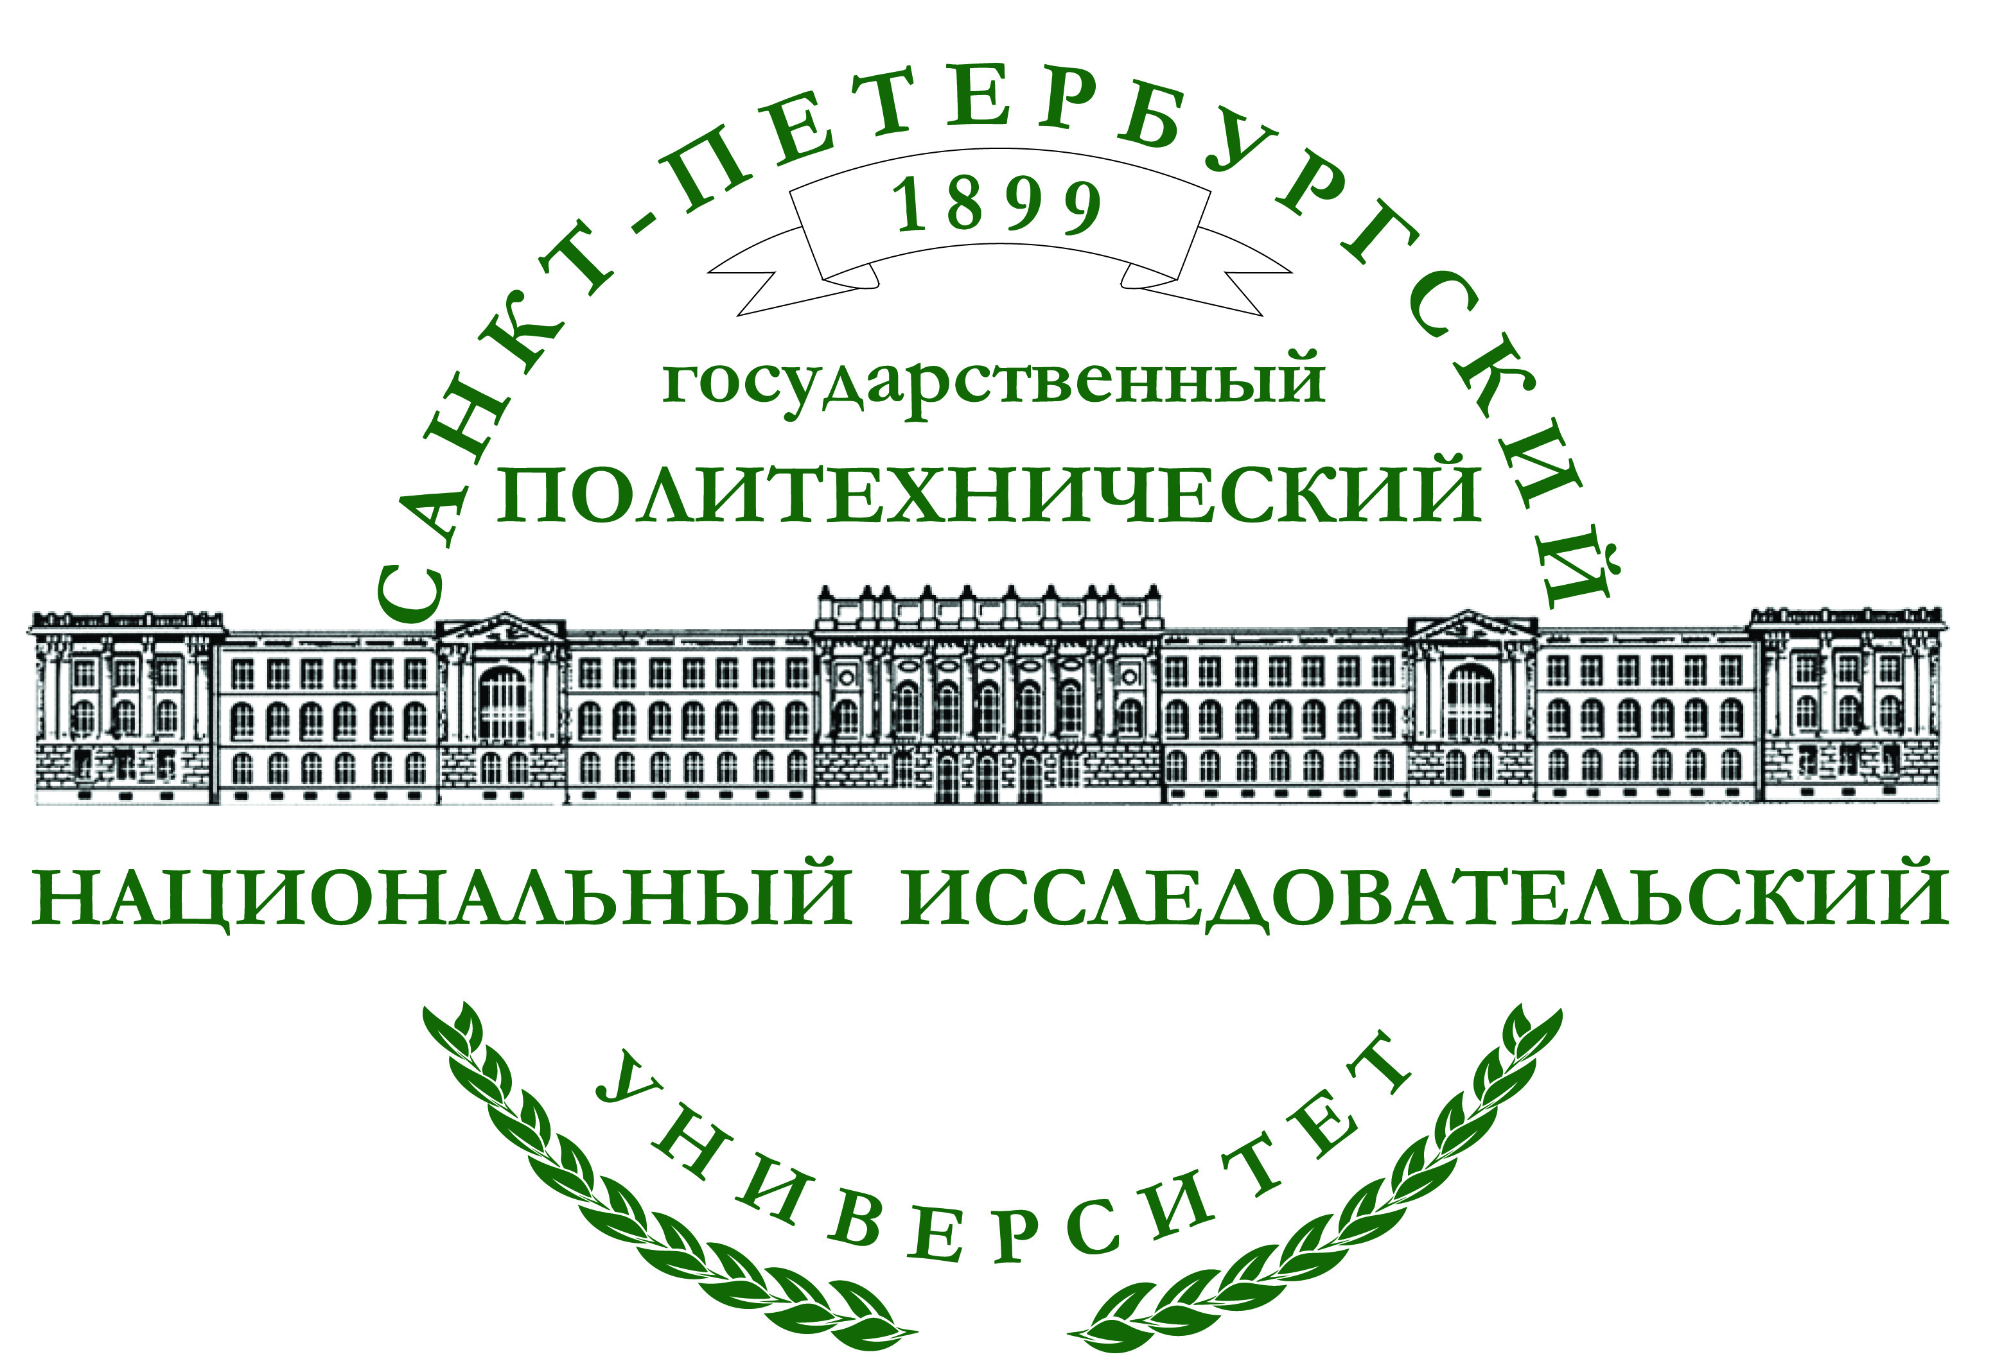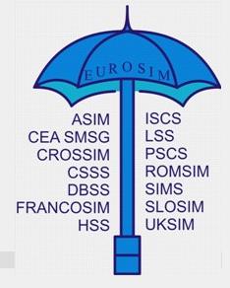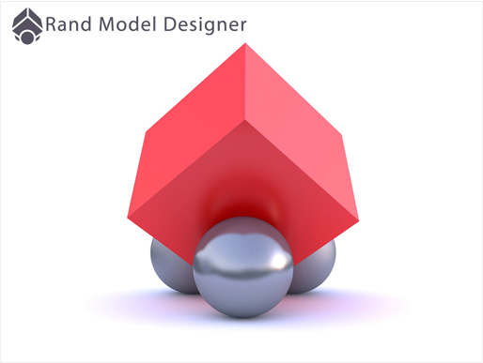

International Scientific and Technical Conference

Computer modeling and simulation - 2015
(COMOD-2015)

 |  | 
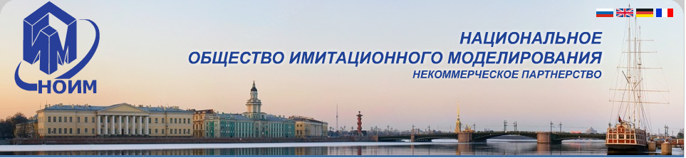
1-3 July, 2015
Saint Petersburg

Chairman of the Conference
Prof. A.I.Rudskoy, corr. member of the RAS (Saint Petersburg)
Co-chairmen
Prof. F. Breitenecker, Ph.D.(Austria)
Prof. Yu.B.Senichenkov (Saint Petersburg)

Program Committee

Prof. A. Grebennikov (Mexico)
Prof. E.A.Novikov (Krasnoyarsk)
Prof. Yu.B. Kolesov (Saint Petersburg)
Prof. N.A.Tseligorov (Rostov-on-Don)
Prof. Yu.V.Shornikov (Novosibirsk)

Organizing Committee

Chairman
Prof. Yu.B.Senichenkov (Saint Petersburg)

Members of the Organizing Committee
Prof. R.M. Yusupov, corr. member of the RAS (Saint Petersburg)
Prof. N.V. Korovkin (Saint Petersburg)
Prof. V.V. Korablev (Saint Petersburg)

A.L.Smirnova - Head of Dept. (Saint Petersburg)

International Organizing Committee:
Prof. F. Breitenecker (Austria)

Prof. A. Grebennikov, Dr. (Mexico)

The purpose of the conference
Complex natural, technical and industrial systems require complex mathematical models and sophisticated technology to develop, research and visualization. The modern visual simulation environments are the basis of these technologies and are used in scientific research, industrial design, education.

We invite developers of modern media of visual simulation, specialists in the field of EMC, mathematical modeling in electrical engineering and electric power industry, users creating with help of these systems mathematical models of complex dynamical systems, scientists, offering new models, methods and simulation software, to talk about their advance in this area and share their experience. We are particularly looking forward to the youth.
International Scientific and Technical Conference will be held on 1-3 July, 2015

at the Saint Petersburg State Polytechnic University.

Participants can choose the preferred working languages ​​- English or Russian. Sections in English and Russian will work independently, and you can listen to the reports of the parallel section, if interesting. Proceedings of the conference will consist of two parts and include reports of both- national and international sections of the conference.
Reviewing the reports will be of two stages - the first stage- selection of the reports to be presented at the conference. The second stage (after the conference) – the reports will be selected and recommended for publication (after completion) in the following journals:
«A New University Magazine» (NUM, in English)
«Simulation Notes Europe» (SNE, in English)
«Scientific and Technical News of SPbPU» (STN, in Russian)
«Computer Tools in Education» (CTE, in Russian)

Attention! Only papers orally presented at the conference can be accepted for publication in journals.

The Conference Sections

Sections of the international and national parts of the conference
- Mathematical and numerical modeling;
- Development and application of visual modeling environment of complex
dynamic systems;
- Modeling in electrical engineering and electric power industry;
- Computer tools in education.
- Projects of young scientists;
Additional sections of the national part of the conference
- Author's presentation of new books;
- Author's presentation of software systems;
- Information about the planned and completed theses;
- Author's lectures about the software products.

Computer Modeling 2015 (working language- English)
Section 1. Mathematical and numerical modeling
(Moderator: A. Grebennikov)
Mathematical models of complex dynamical systems. Numerical simulation of complex dynamical systems - methods and software. Tools for computational experiments.

Section 2. Development and application of visual simulation environment of complex dynamical systems
(Moderator: Yu .B. Senichenkov)
Languages of ​​object-oriented modeling. Architecture and capabilities of visual modeling (simulation) environments. Methods of automatic formation and transformation of mathematical models. Numerical libraries of simulation environments. Organization of computational experiment. Debugging and verification of computer models. Applied libraries. Tools for research, testing and optimization of computer models.

Section 3. Modeling in electrical engineering and electric power industry
(Moderator: N.V. Korovkin)
Grounding;
Smart Grid Technology & Applications;
Stability, Reliability and Security;
Power Quality;
Control of power systems and related issues;
Power Saving Technologies;
FACTS Technologies;
Optimization Techniques in Power Engineering;
Application of Soft Computing Techniques in Power System Design & Management;
Future Energy Technologies;
Renewable Energy Sources;
Superconductivity Application in Power Engineering.

Section 4. Computer Tools in Education
Moderators: A.I. Grebennikov, N.V. Korovkin, Yu .B. Senichenkov)
Technologies of development and use of computer models in education, training computer models for different areas, new laboratory works, textbooks and lectures on modeling. Propaganda of modeling: competitions, journals, and publishing projects.

Section 5. Projects of young scientists
(Moderator: Yu. B. Senichenkov)
Computer models, new areas and methods for design and research of computer models, simulation software and systems research, created by graduate and PhD students.

Section 6. Author's presentation of new books

Authors of books, textbooks, educational and methodological complex on the conference subjects are invited.

Section 7. The author's presentation of software products

Authors of the program complexes on the conference subjects are invited.

Section 8. Presentation of planned and completed dissertations
All who are interested to discuss their dissertations on the conference subject are invited.

Section 9. Author's lectures about software products with subsequent issuance of certificates

Authors of software products capable during 6 lectures and 3 workshops to teach the participants to work with their products and give certificates those who successfully passed the final test are invited.
The Rend-service company and Saint-Petersburg State Polytechnical University conduct a course of video-conferences «Using Rand Model Designer in the industry and education». This distance learning course will be completed in computer classes during the conference days. Students who successfully complete the training will receive a certificate from the Rend-service company.

Form of presentation and type of publication

№ | Form of presentation | Language | Publication in the Conference Proceedings
1. | Sectional paper*) | Engl./Russian | COMOD(Engl.)  КОМОД(Russian)  Abstract (1/2 page)  Paper
2. | Invited paper**) | English | COMOD (Engl.)  КОМОД (Русский)  CV (1page + photo)  Abstract (1page)  Paper

*)After reviewing all the reports will be divided into two groups: sectional presentations and poster presentations. Only papers of the second group (sectional and invited papers) and all abstracts of the poster presentations will be published in the CONFERENCE PROCEEDINGS.
**)To be invited speaker you have to send to the Organizing Committee: application, brief biography(CV)- (1 p. + photo), abstract (1 p.). After the official invitation- to send your report for publication (10 p.). Invited speakers open the conference, their report lasts 30 minutes, and they are exempt from paying the registration fee.

Sectional papers can be recommended for publication in journals.

Conference Proceedings will be presented on USB flash drive.
Printed copy of the Proceedings will be available upon prior request at the Organizing Committee for an additional fee.

How to submit abstracts and papers at the conference
All abstracts/papers are accepted only via the conference-machine .easychair.org. To submit abstract/paper, the author must register on the conference page in the conference machine at https://easychair.org/conferences/?conf=comod2015, get login and password, visit the conference page and upload a single file of your abstract and/or paper. All downloaded materials should be submitted as pdf files..

Abstracts/reports sent by e-mail will not be considered.

Rules for abstracts and papers
All abstracts/reports must be submitted in strict accordance with the template and will be checked automatically. Mismatch template can serve as a formal reason for rejection of abstract/report. You can see the template and download it at: http://dcn.icc.spbstu.ru in section Conference/COMOD-2015.

Important dates

- 1st May 2015 – deadline for the final version of the report submission
Attention! Notification of your paper acceptance you will receive two weeks after the upload of the final version of the paper.
- 15 May 2015 –deadline for the author notification that his report/abstract is accepted
Attention! Your paper will be included in the Conference proceedings only after the payment of the registration fee.
Conditions for participation in the Conference
International Scientific and Technical Conference will be held on 1-3 July, 2015 in the St. Petersburg State Polytechnic University (room 118 of the Main Education Building). Address: ul. Politekhnicheskaya 29 (Metro station "Politekhnicheskaya").
Registration fee includes : a conference set with the Conference Proceedings on the USB flash drive, coffee -breaks, lunches and boat trip across rivers and canals of St. Petersburg with a gala dinner on the board, transfer to the boat and back.

Excursions to Peterhof and Tsarskoye Selo (Catherine Palace and Park with visiting the Amber room) are extra paid.

To participate in the Conference: send the registration form to the email address: COMOD15@spbstu.ru
File name with a registration form must include the name and initials of the participant. For example: ivanov_ak_reg.

Registration fee
Foreign participants - 350 euro

Postgraduate students and students - 150 euro

Payment methods

For EUR

Intermediary bank: 0103053393
VTB Bank (Deutschland) AG, Frankfurt am Main
SWIFT: OWHBDEFF
Beneficiary, s bank: JSC VTB BANK (OPERU BRANCH)
30 B. Morskaja str, 190000 St Petersburg, Russia
SWIFT: VTBRRUM2NWR
Beneficiary: account 40503978939040000020
St. Petersburg State Polytechnic University (SPbPU),
29, Polytechnicheskaja str, St Petersburg, Russia

In the payment by bank transfer, please do not forget to write the title of the Conference (COMOD-2015) and your name.

All information on bank accounts see also on the Conference website: http://dcn.icc.spbstu.ru ,
section Conferences/COMOD-2015 and http://www.spbstu.ru/conference/2015/2015.asp

You can pay by bank transfer or by cash at registration (in rubles).
Participants wishing to pay by a bank must cover transaction charges.

Accommodation
1. Hotel "Sputnik" *** (Prosp. Morisa Toreza 36, Metro station “ Ploschad‘
Мuzhestva“)
2.University Hostel**

NB: Hotel reservation is carried out through the Organizing Committee of the Conference.

Information for contact
Organizing Committee of SPbSPU
ul. Politekhnicheskaya 29

195251 Saint Petersburg

Russian Federation

General information:
Alla L.Smirnova
Tel/fax: +7 (812) 297 20 88

expert@spbstu.ru

Lidia Papina
Tel/fax: +7 (812) 552 85 34
COMOD15@spbstu.ru

Abstracts/papers submission:
Yuriy B. Senichenkov
Elena A. Slok
Tel/fax: +7 (812) 297- 16 39
+7(812) 297 07 29

cm_org@dcn.icc.spbstu.ru

Conference website: http://dcn.icc.spbstu.ru ,
section Conferences/COMOD-2015 and

http://www.spbstu.ru/conference/2015/2015.asp

International Scientific and Technical Conference
Computer modeling and simulation-2015
(COMOD-2015)

Registration Form

Title: Mr  Mrs  Ms  Prof  Dr 
Last Name ________________________
First Name ________________________
Other Names ______________________
Dates of birth______________________
Place of birth_______________________
Citizenship________________________
Passport number____________________
Date of issue______________________
Date of expiry______________________
Country of permanent residence________
Place of visa issuing_________________
Place of work:
Organization_______________________
Address___________________________
Position___________________________
E-mail____________________________
Fax______________________________
Phone_____________________________
Accompanying person, if any___________
Date of arrival_______________________
Date of departure____________________

I am going to present a paper at the conference  Yes  No
I need to present a paper  Yes (Type of equipment)  No
I am bringing a poster  Yes  No

Please note! Copy of the first page of your passport sent by fax or by e-mail is necessary for visa proceedings. Visa support letter (official invitation) will be sent to you within 2 months (for EU members within 2 weeks).

Accommodation needed:  Yes  No
If yes:
Hotel “Sputnik”  Yes  No
-  single room
-  double room

Address: Hotel “Sputnik”- Prosp. M.Toreza 36;
metro station “Ploshchad’ Muzhestva”

University Hostel**  Yes  No
-  single room
-  double room

Address: (Grazhdanskiy prosp. 28, metro station
“Akademicheskaya“)

Date and Place_______________

Signature ___________________

