**Institute of Physics, Nanotechnology and Telecommunications,**

**Saint Petersburg State Polytechnic University**

**Central Astronomical Observatory at Pulkovo  
of the Russian Academy of Sciences**

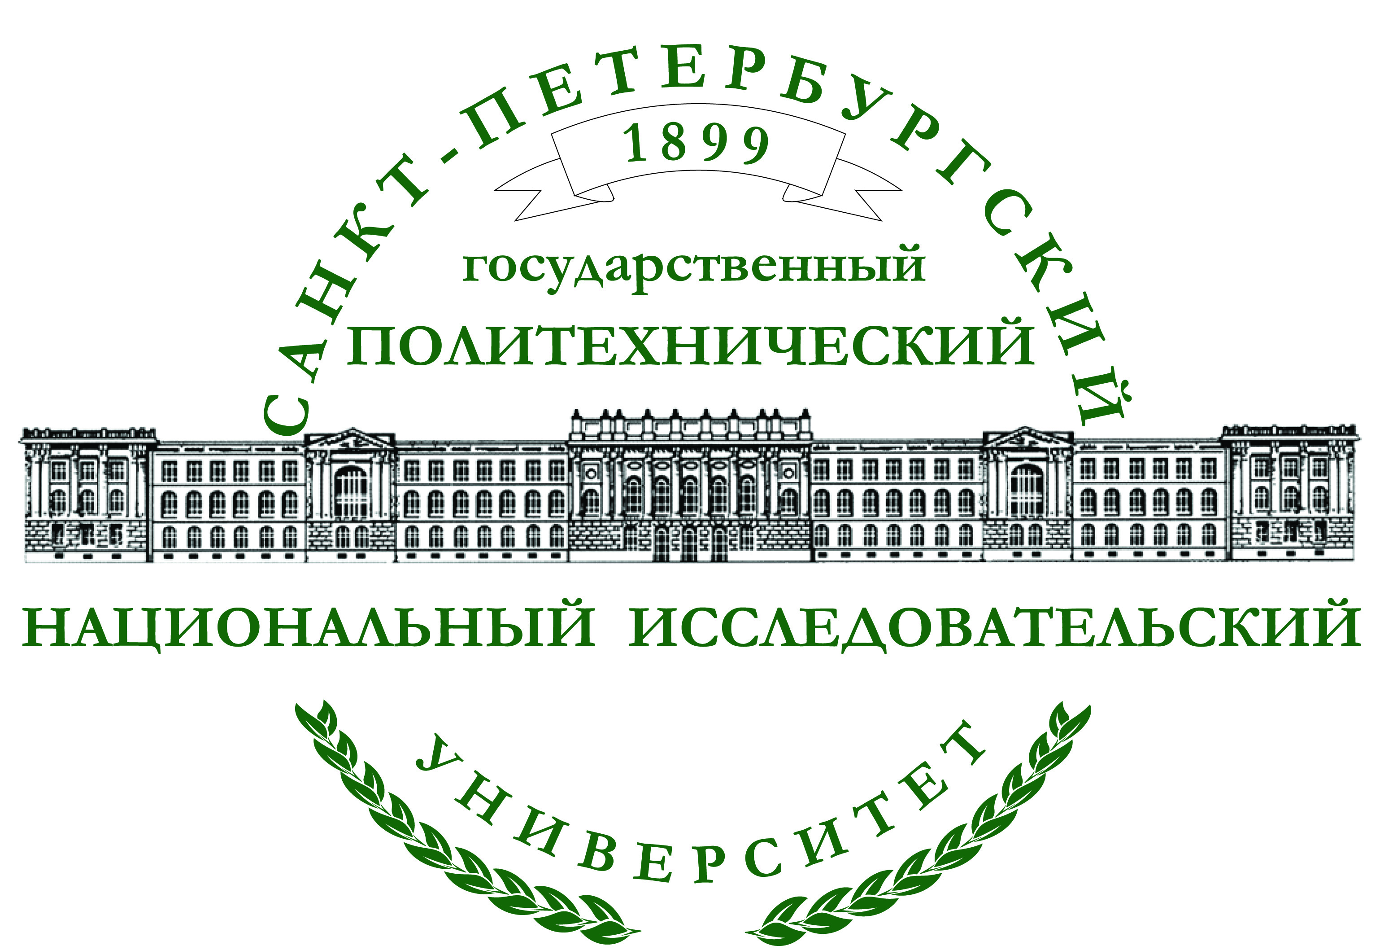



***THE NINTH ALEXANDER FRIEDMANN INTERNATIONAL SEMINAR***

***ON GRAVITATION AND COSMOLOGY***

***AND THIRD SATELLITE SYMPOSIUM***

***ON THE CASIMIR EFFECT***

**June 22 –26, 2015**

**Saint-Petersburg**

***It is a pleasure to announce***the Ninth Alexander Friedmann International Seminar on Gravitation and Cosmology and ThirdSatellite Symposium on the Casimir Effect to be held from June 22, 2015 toJune 26, 2015. **The remarkable fact is that the 9th Friedmann Seminar is organizing and will take place at St. Petersburg State Polytechnic University, where Alexander Friedmann was working as a Professor during his most productive years from 1920 to 1925. There is a historical evidence that several students of the Polytechnic University were among the first persons who have recognized from Friedmann himself about his recently developed theory of expanding Universe.**

The working language of the Ninth Friedmann Seminar and Third Casimir Symposium is English.

***SCIENTIFIC ORGANIZING COMMITTEE***

* A. I. Rudskoy, Chairman, Russia
* S. B. Makarov, Vice-Chairman, Russia
* V. M. Mostepanenko, Vice-Chairman, Russia
* V. M. Petrov, Vice-Chairman, Russia
* Yu. V. Pavlov, Scientific Secretary, Russia
* V. B. Bezerra, Brazil
* E. R. Bezerra de Mello, Brazil
* G. Bimonte, Italy
* M. Bordag, Germany
* Yu. N. Gnedin, Russia
* A. A. Grib, Russia
* G. L. Klimchitskaya, Russia
* V. N. Melnikov, Russia
* U. Mohideen, USA
* M. Novello, Brazil
* C. Romero, Brazil
* A. A. Starobinsky, Russia
* R. K. Tavakol, England
* I. N. Toptygin, Russia
* R. Triay, France
* D. A. Varshalovich, Russia

***LOCAL ORGANIZING COMMITTEE***

* A. I. Borovkov, Co-Chairman, Russia
* D. Y. Raychuk, Co-Chairman, Russia
* E. N. Velichko, Russia
* **V.V. Korablev, Russia**
* C. C. Korikov, Russia
* E. M. Smirnov, Russia
* **A. L. Smirnova, Russia**

***SCOPE***

The objective of the meeting is to promote contacts between scientists working in the field of Relativity, Gravitation and Cosmology and related fields. It is well known that the important role in Gravitation and Cosmology is played by the Casimir effect. To underline this, special Satellite Symposia devoted to this effect have been included in the Programs of the 7th and 8th Friedmann Seminars. The Casimir effect is a multidisciplinary subject. Its applications extend from gravitation and cosmology to the van der Waals forces, materials properties and nanotechnology. All these subjects are traditionally touched at the Satellite Simposia on the Casimir effect.

***TOPICS***

The main topics to be discussed at the 9th Friedmann Seminar and the 3rd Casimir Symposium are the following:

Ninth Alexander Friedmann Seminar:

* Classical gravity
* Observational and theoretical cosmology
* Quantum effects in curved space-time
* Quantum gravity
* Gravitational theory with extra dimensions
* Geometrical aspects of gravitational theory

Third Symposium on the Casimir Effect:

* Casimir and van der Waals forces (including the role of materials properties, experiment and nanotechnological aspects)
* Quantum Electronics and nanotechnologies
* Modeling of electromagnetic field-matter interaction and precise measurements

***PROCEEDINGS***

The Proceedings of the 9th Friedmann Seminar and the 3rd Satellite Symposium will be published as special issues of the **International Journal of Modern Physics A** and **International Journal of Modern Physics: Conference Series** after the finish of these events.The papers submitted for publication in the Proceedings will be refereed following the standard procedures.

All submissions should be prepared in LaTeX following the style-file which will be posted at the website later. Please find all details concerning the Ninth Friedmann Seminar and the Third Satellite Symposium in the Internet site

<http://friedmann-2015.org/>

## *IMPORTANTDATES*

## 15.05.2015 – deadline for registration

## 30.09.2015 – submission of full papers

## *REGISTRATION*

**The Seminar registration fee is US $200**

**Payment methods**

Bank account to pay registration fee:

Intermediary bank: 36208997

CITIBANK N.A.

SWIFT: CITIUS33

Beneficiary, s bank: JSC VTB BANK (OPERU BRANCH)

30 B. Morskaja str, 190000 St Petersburg, Russia

SWIFT: VTBRRUM2NWR

Beneficiary:account 40503840539040000024

St. Petersburg Polytechnic University (SPbPU),

29, Polytechnicheskaja str, St Petersburg, Russia

**In the payment by bank transfer, please do not forget to write the title of the conference ( Alexander Friedmann International Seminar ) and your name.**

**Participants wishing to pay through a bank must cover transaction charges.**

**Also the registration fee can be paid in cash at registration.**

The Organizing Committee hopes that it will manage to pay the registration fee for a limited number of participants from the former Soviet Union and developing countries.

Conference fee covers a conference bag, participation in all sessions and conference events (coffee breaks, welcome party and excursion), Program and Proceedings.

For participation in the 9th Friedmann Seminar and the 3rd Casimir Symposium, please fill out the Registration Form below and send it as an attached file to the address of our Scientific Secretary Dr. Yuri V. Pavlov:[yuri.pavlov@mail.ru](mailto:yuri.pavlov@mail.ru)

Please indicate the following information about you. Using this information, we will issue the official invitation which you might need to get the Russian visa from the Russian Consulate (if necessary) or the funding of your participation from your National funding Agencies.Please note that to issue the official invitation letter suitable for obtaining the Russian visa at the Russian Consulate we will need a copy of the first page of your passport.

**Registration Form**

* Family name
* Given names
* Date of birth
* Place of birth
* Nationality
* Passport number
* Date of issue
* Date of expiration
* Place of visa issuing
* Country of residence
* Affiliation with a mailing address
* Position
* E-mail address
* Phone/Fax number
* Title of the talk
* Paper/Poster
* Accompanying person, if any
* Accommodation needed: Yes/ No
* Date of arrival
* Date of departure

We will confirm the receiving of each Registration Form by e-mail.Your participation is welcomed and we hope to see you at Saint Petersburg in the end of June, 2015!

## *ACCOMMODATION*

We recommend you to make the Hotel reservation at St. Petersburg through the local Organizing Committee of the Ninth Friedmann Seminar and Third Casimir Symposium. In case the hotel reservation is carried out through the local Organizing Committee, we will arrange special prices and guarantee a proper accommodation for the participants. The available Hotels are the following:

***Hotel “Sputnik”***(single rooms, double rooms), pr. M.Toreza 36; metro station “Ploshchad’ Muzhestva”,

***Hotel “Moscow”***(single rooms, double rooms), address: Alexander Nevsky sq, 2, metro station “Ploshchad’ Alexandra Nevskogo”,

Business Hotels belonging to the Polytechnical University and Pulkovo Observatory(single rooms, double rooms).

## *VENUE*

## The Conference will be held at the St. Petersburg Polytechnic University to the address: 29 Politekhnicheskaya str. (metro station "Politekhnicheskaya"), at the Main Education building.

***CONTACT INFORMATION OF THE ORGANIZING COMMITTEE***

**Scientific Secretary** (registration, invitations for obtaining support from your local sources, scientific program and proceedings)

Dr. Yuri V. Pavlov: [yuri.pavlov@mail.ru](mailto:yuri.pavlov@mail.ru)

**Head of the Congress Activity Department** (organization questions including invitations for obtaining visas and accommodation)

Alla Smirnova: [committee@friedmann-2015.org](mailto:committee@friedmann-2015.org)

Tel / fax: +7 (812) 297 20 88

## *CONFERENCE WEBSITE*

<http://friedmann-2015.org/>