Announcement for the First Meeting and Call for Papers

St. Petersburg Polytechnic University

St. Petersburg State University

Leibniz Universität Hannover
Friedrich-Alexander Universität Erlangen-Nürnberg
St.Petersburg society of German classical philosophy
St.Petersburg Nicolai Cusanus society
St.Petersburg Martin Luther society

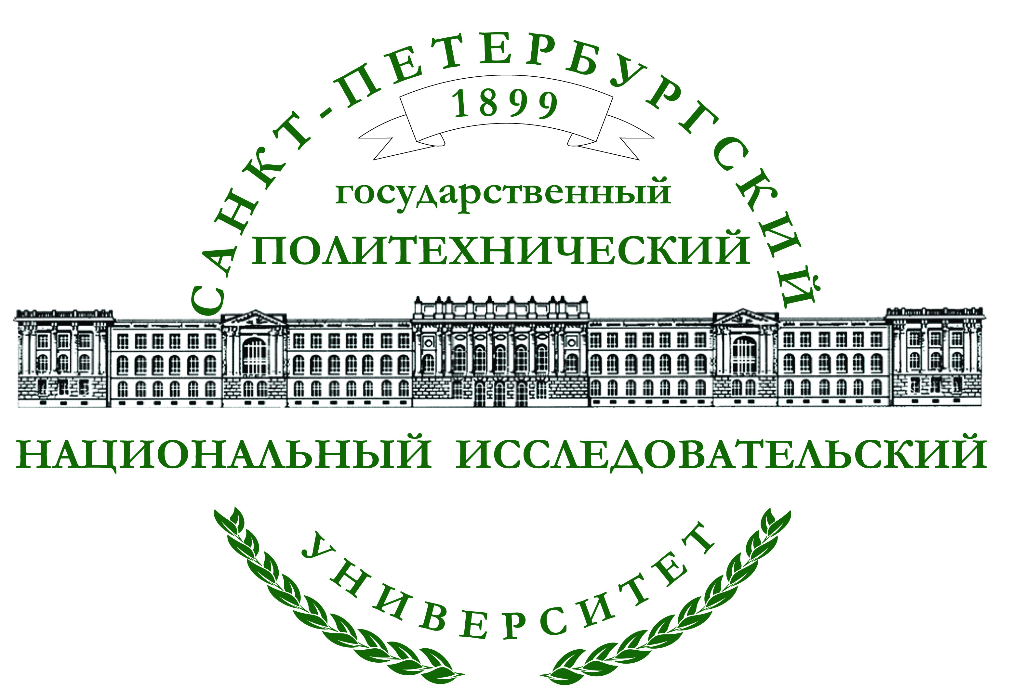

International Scientific Conference
"500 YEARS OF REFORMATION AND NEW TIME: 1517-2017"

(The era of Reformation as the spiritual 500-years resource of European philosophy, culture and science of New Time. International Research of Scientific, Historical, Social, Cultural, Philosophical and Theological Influence of Reformation on New Time since 1517 till 2017)

April 16 - 19, 2015

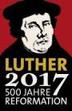

Saint Petersburg

2015

Conference Chairman

Dr. Iwan Phokin, Professor of St. Petersburg Polytechnic University

Program Committee
Chairmen:

Dr. Sergej Pogodin, Professor of St. Petersburg Polytechnic University
Dr. Walter Sparn, Professor of Friedrich-Alexander Universität Erlangen-Nürnberg

Dr. Alexej Malinov, Professor of St. Petersburg State University

Dr. Friedrich Wenzel, Professor of Leibniz Universität Hannover
Dr. Oleg Doshin, Professor of St. Petersburg State University, St.Petersburg Nicolai Cusanus society
Dr. Iwan Phokin, Professor of St. Petersburg Polytechnic University, St.Petersburg society of German classical philosophy, St.Petersburg Martin Luther society.

Objectives and topics of the conference
The conference is supposed to consider and discuss the spiritual Reformation of XVI century as a cultural and historical background of the scientific worldview of New (Modern) Time, the Modern picture of the world, Modern Thinking and Modern Understanding of Human Nature.

Thematic Sections
- New Worldview of New Time in compare with the Middle Ages (approximately since the middle of XV century; since Columbus, Huttenberg, Kepler, Galileo, Kopernicus and others).
- Religious Reformation and its important Meaning for Science, Religion and Culture during the whole Period of a New Time: 1517-2017.
- Reformation as the spiritual ground and Way of Culture, Science and Philosophy of a New Time: from 1517 to 2017.
The Aim of the Conference.
- Annual meeting (from two to five days) of the international researchers to exchange views on the correct interpretation of the Reformation and New times, finally coming after the reformation of Martin Luther.
- Inter-disciplinary attitude towards the work of Martin Luther’s Reformation and New Times: historians, sociologists, theologians, philosophers, aesthetics, art specialists and other academics meet on a regular basis to investigate all aspects of Martin Luther’s Reformation and New Times.
- Representatives of all faiths are invited as participants and speakers. This will give a better understanding of the epoch of the Reformation in general, including from the point of view of other faiths and of all Christian denominations.
International exchange of views on Martin Luther’s Reformation: the Conference is designed to attract scholars from around the world to meet and discuss important metaphysical questions of the new history and the present time. The first session of the conference will be held 16-19 April 2015 in St. Petersburg Polytechnic University of Peter the Great (SPbPU). There is hope that further meetings in 2016 and 2017 will be also held in SPbPU, and in subsequent years, probably in the universities of other countries. Final details of the program will be arranged in co-operation with participants, hosts/organizers and the founders of the Conference.
- Preparation of reports does not imply any one official research language, but the official language of the Conference is English in order to preserve and maintain the international character of the conference. This means that the participants can orally present their material (point of view) in any language they wish, but they should submit a written paper in English. All potential participants should submit a brief summary (CV), title, and abstract (no more than 1000 words) in English to the Conference Organizing Committee.
- Proceedings of the Conference will be published by the host/organizer of the Conference in co-operation with the Conference founders.
- The final details of the program for each Conference will be taken by the host/organizer of the Conference in co-operation with the Conference founder.

Important dates
10th December, 2014 – deadline for abstract submission (1-2 pages of А4
paper in Word)

25th January, 2015 – deadline for abstracts review

1st March, 2015 – submission of full papers.
If you wish to participate as a speaker, please send by the end of February 2015, an
e-mail with your abstract (350-500 words), and a short CV to
Prof. Dr. Iwan Phokin, iwan.phokin@mail.ru

The International Relations Department will publish the materials in its collection of papers “International Relations and Dialogue of Cultures”.

Events planned during the conference:
- Visit to the chapel (or Philharmonic)
- Bus city tour
- Attending Sunday services at the German Evan.-Lutheran Church of Peter and
Paul (Nevsky, 22) - Sunday, April 19, 10:30-12:00
Welcome party is possible depending on the number of participants.

Venue
The Conference is to be held in Saint-Petersburg Polytechnic University at the address: Grazhdansky pr. 28 , Conference Hall (Metro station "Akademicheskaya").

